**Full Stack Development with MERN**

**Project Documentation format**

**BookNest – Where Stories Nestle**

**(MERN Stack Online Book Store)**

**Introduction**

**🔹 Project Title: BookNest – Where Stories Nestle**

**🔹 Team Members:**

| **Name** | **Role** |
| --- | --- |
| Team Leader | Full Stack Developer (Frontend + Backend) |
| Team Member 2 | UI/UX Designer |
| Team Member 3 | Backend Developer |
| Team Member 4 | Database & Deployment Engineer |

**2️⃣ Project Overview**

**🔹 Purpose:**

BookNest is a full-stack MERN application designed to provide a secure, user-friendly online platform for browsing, searching, and purchasing books. The goal is to create a modern, scalable bookstore with smooth navigation and secure authentication.

**🔹 Key Features:**

* User Registration & Login (JWT Authentication)
* Browse 100+ Books with images
* Search books by title or author
* Add to Cart functionality
* Place Orders
* View Order History
* Cloud Deployment (Render + Vercel)
* Secure MongoDB Atlas database

**Architecture**

**🔹 Frontend (React.js – Vite)**

* Component-based architecture
* Pages: Home, Register, Login, Books, Cart, Orders
* Axios used for API calls
* Protected routes for authentication
* Hosted on Vercel

🔹 Backend (Node.js + Express.js)

* RESTful API structure
* JWT authentication
* Middleware for validation
* CORS configured for production
* Hosted on Render

🔹 Database (MongoDB Atlas)

Collections:

* Users
* Books
* Orders

Database Interactions:

* Mongoose models
* CRUD operations
* Cloud-hosted NoSQL database

**Setup Instructions**

**🔹** Prerequisites

* Node.js (v18+)
* MongoDB Atlas account
* Git
* npm

**🔹 Installation**

**Step 1: Clone Repository**

**git clone** https://github.com/Kushulatha-k/BookNest.git

**cd booknest**

**Step 2: Backend Setup**

cd backend

npm install

Create .env file:

PORT=5000

MONGO_URI=your_mongodb_connection_string

JWT_SECRET=your_secret_key

Run backend:

npm run dev

**Step 3: Frontend Setup**

cd frontend

npm install

npm run dev

**Folder Structure**

🔹 Client (Frontend)

frontend/

├── src/

│ ├── components/

│ ├── pages/

│ ├── api/

│ ├── App.jsx

│ └── main.jsx

├── package.json

🔹 Server (Backend)

backend/

├── models/

├── routes/

├── config/

├── server.js

├── package.json

└── .env

**Running the Application**

🔹 Frontend

cd frontend

npm run dev

Runs at:

http://localhost:5173

🔹 Backend

cd backend

npm run dev

Runs at:

http://localhost:5000

**API Documentation**

**🔹** User Routes

| Method | Endpoint | Description |
| --- | --- | --- |
| POST | /api/users/register | Register new user |
| POST | /api/users/login | Login user |

Example Request:

{

"email": "user@gmail.com",

"password": "123456"

**}**

**🔹 Book Routes**

| Method | Endpoint | Description |
| --- | --- | --- |
| GET | /api/books | Get all books |
| GET | /api/books/seed | Seed books |

**🔹 Order Routes**

| Method | Endpoint | Description |
| --- | --- | --- |
| POST | /api/orders | Place order |
| GET | /api/orders/myorders | Get user orders |

**Authentication**

* JWT-based authentication
* Token stored in localStorage
* Protected routes
* Password encrypted using bcrypt
* Middleware validates token before accessing protected APIs

**User Interface**

The UI includes:

* Animated backgrounds
* Responsive design
* Card-based book layout
* Navigation bar
* Styled cart and order pages

(Screenshots included in README)

**Testing**

**Testing Strategy:**

* API Testing using Postman
* Manual Integration Testing
* Authentication Testing
* Deployment Testing

All modules tested before production deployment.

**Screenshots / Demo**

**🔗 Live Demo:**

**Frontend:** [https://book-nest-six-topaz.vercel.app/](%20%20https:/book-nest-six-topaz.vercel.app/)

**Backend :**  <https://booknest-backend-0buw.onrender.com>

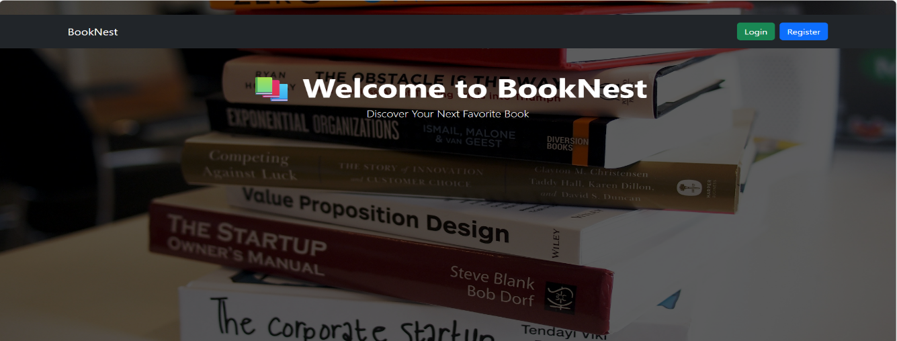



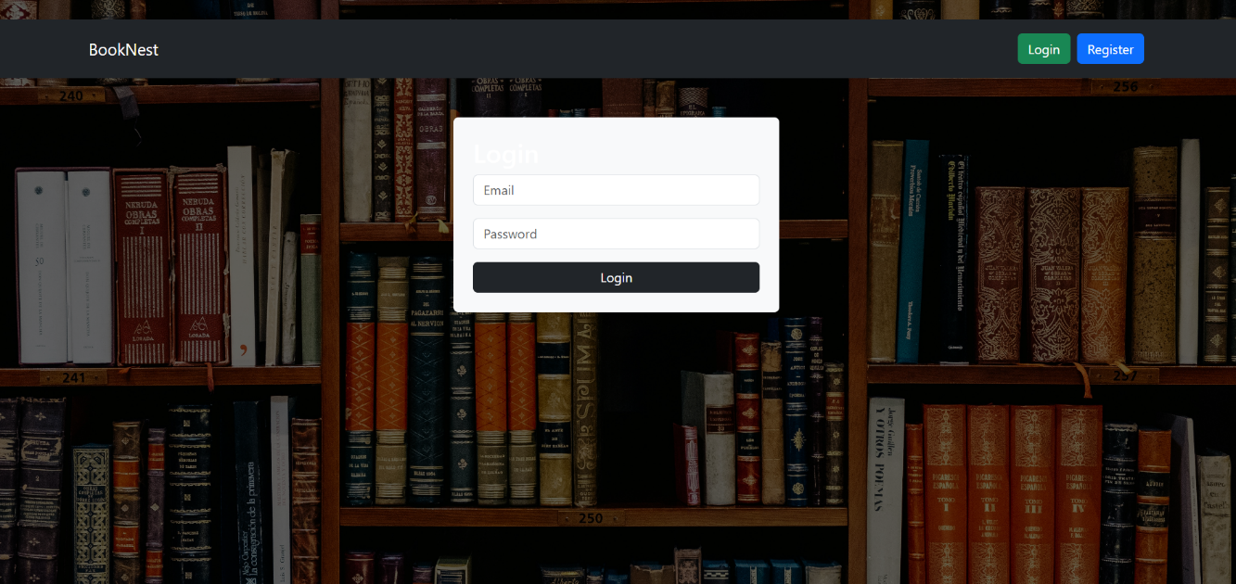

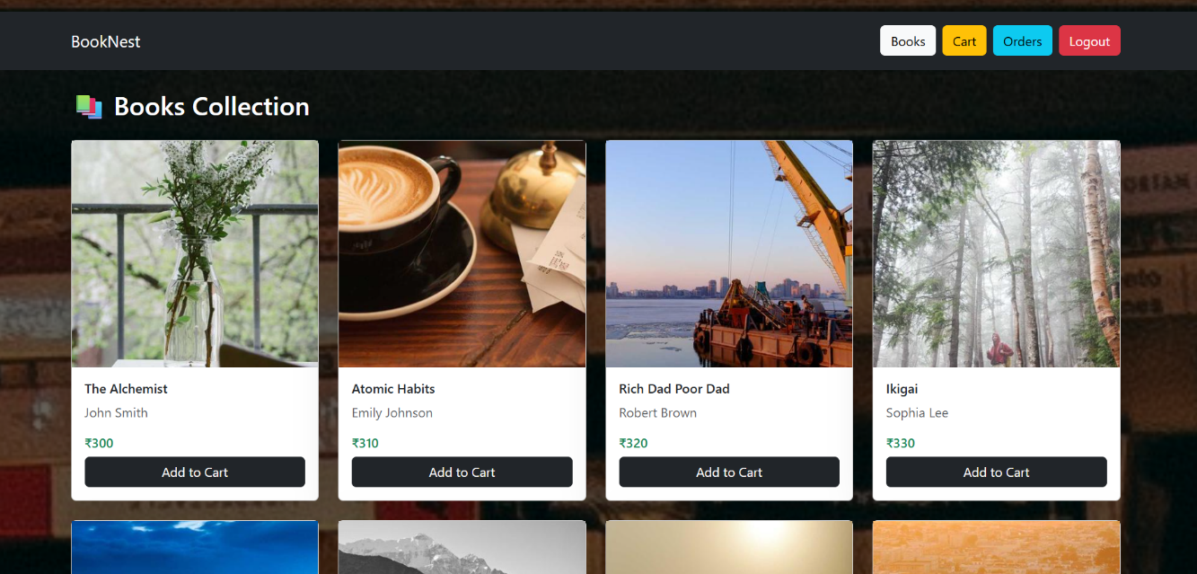

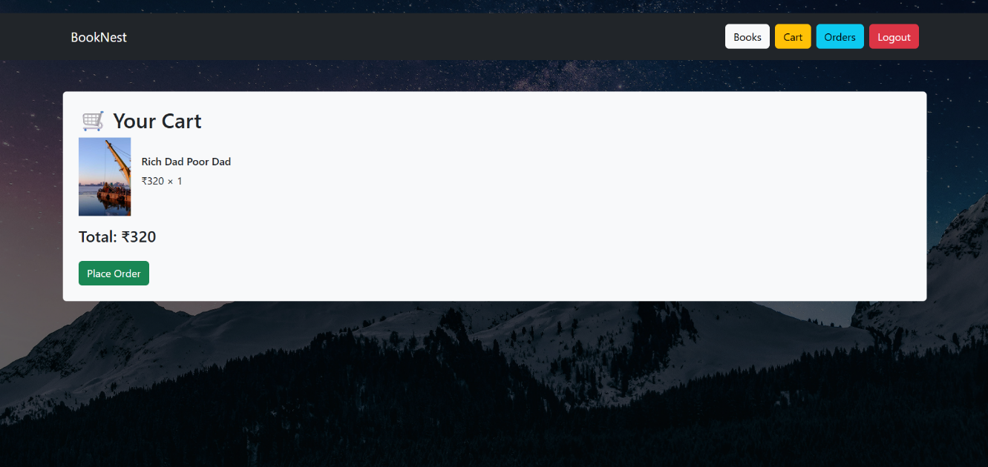

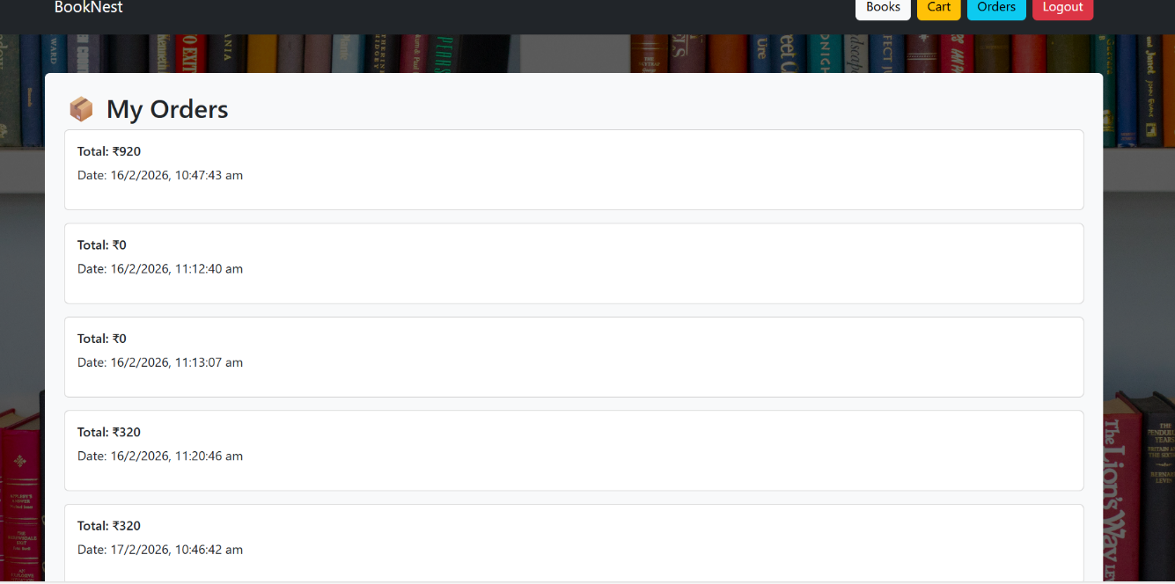

**Known Issues**

* No payment gateway integration (currently demo order placement)
* No email verification
* Limited admin dashboard features
* Basic search (no AI recommendation yet)

**Future Enhancements**

* Payment Gateway Integration (Stripe/Razorpay)
* AI-based Book Recommendation System
* Admin Dashboard
* Order Tracking
* Mobile Application (React Native)
* Wishlist Feature
* Review & Rating System

**Conclusion :** BookNest is a scalable MERN stack application that provides a secure, modern online bookstore platform. It demonstrates full-stack development, cloud deployment, authentication, and REST API integration using modern web technologies.